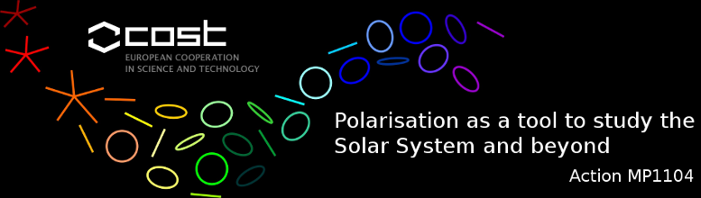

STSM Scientific Report
Applicant and home institution : Dr. STANISLAV GUNÁR, School of Mathematics and Statistics, University of St Andrews, St Andrews, UK
Visited scientist and host institution : Dr. DAVID OROZCO SUÁREZ, Instituto de Astrofisica de Canarias, La Laguna, Tenerife, Spain
Dates of STSM : June 26, 2015 – July 3, 2015

Explain briefly below how your STSM matched one of these key-points :
- establish new collaborations
We have fulfilled the primary goal of the present COST Short Term Scientific Mission which was to initiate the collaboration of Dr. S. Gunár with Dr. D. Orozco Suárez and with other members of the Solar Magnetism and Astrophysical Spectropolarimetry research group of the Instituto de Astrofisica de Canarias (IAC).
During his visit at IAC, S. Gunár held multiple scientific discussions with D. Orozco and also with Prof. J. Trujillo Bueno and other members of the group, notably Dr. M. Luna Bennasar. During these discussions S. Gunár shared his expertize in the 3D modelling of entire quiescent prominences with multiple prominence fine structures. He also shared his expertize in the techniques used for 3D prominence modelling, such as the prominence magnetic field simulations, prominence plasma modelling and the radiative transfer computations. These various techniques can be utilized by the members of the Solar Magnetism and Astrophysical Spectropolarimetry group for various projects considering solar prominences. These intense scientific discussions were also instrumental for S. Gunár in gaining insight into the modelling of the polarized radiation and inference of the prominence magnetic field properties from observations, specifically using the 1083.0 nm spectral line of helium. D. Orozco and J. Trujillo are among the world leading experts in this field.

his expertize on the complex modelling of the prominence fine structures developed in collaboration with Prof. P. Heinzel from the Astronomical Institute of the Academy of Sciences of Czech Republic and with Dr. U. Anzer from the Max-Planck-Institut für Astrophysik. Within the subsequent scientific discussions with Prof. J. Trujillo Bueno and members of his research group, notably Dr. D. Orozco Suarez, and with Dr. J. Štěpán from Astronomical Institute of the Academy of Sciences of Czech Republic we have discussed the initial stages of joint development of the prominence fine structure models coupling the established modelling of the prominence plasma and radiative transfer of S. Gunár with the multi-dimensional modelling of the polarized radiative transfer developed at the Instituto de Astrofisika de Canarias.
to share the expertize of S. Gunár on the prominence modeling and the newly developed 3D WPFS models, as well as the expertize of D. Orozco Suárez with the inference of the magnetic field properties from prominence observations. We will discuss the possibilities and challenges of the proposed development of the polarized radiative transfer methods for synthesis of the He 10830 line and its use for enhancement of the inversion techniques.

Describe below the activities carried out during the STSM and the main results obtained.
Within the scope of the present COST STSM we have initiated collaboration with D. Orozco on a joint project of development of techniques for polarized radiation synthesis of helium 1083.0 nm spectral line using the 3D whole-prominence fine structure (WPFS) model of S. Gunár and D. Mackay. Within this collaboration we will use the 3D models on individual prominence fine structures as a starting point for the modelling of the polarized radiative transfer in the 1083.0 nm line. This effort will be later widened to encompass multiple prominence fine structures produced by the 3D WPFS model. The synthetic spectropolarimetric information in the 1083.0 nm line obtained from realistic distribution of the prominence magnetic field and plasma will serve as excellent controlled input for validation and enhancement of the inversion techniques used for inference of the magnetic field properties from prominence observations. The reliable inversion techniques are a critical component of the current pursuit of high resolution spectropolarimetric observations of the solar prominences. The results of this project will be presented at major international conferences and published in major scientific journals.
During the current STSM we have concentrated on defining the interfaces between the existing codes and on the understanding of the possibilities and challenges of the project. S. Gunár has also presented a lecture on the High-resolution fine-structure synthetic imaging of an entire prominence using 3D whole-prominence fine structure modelling.

